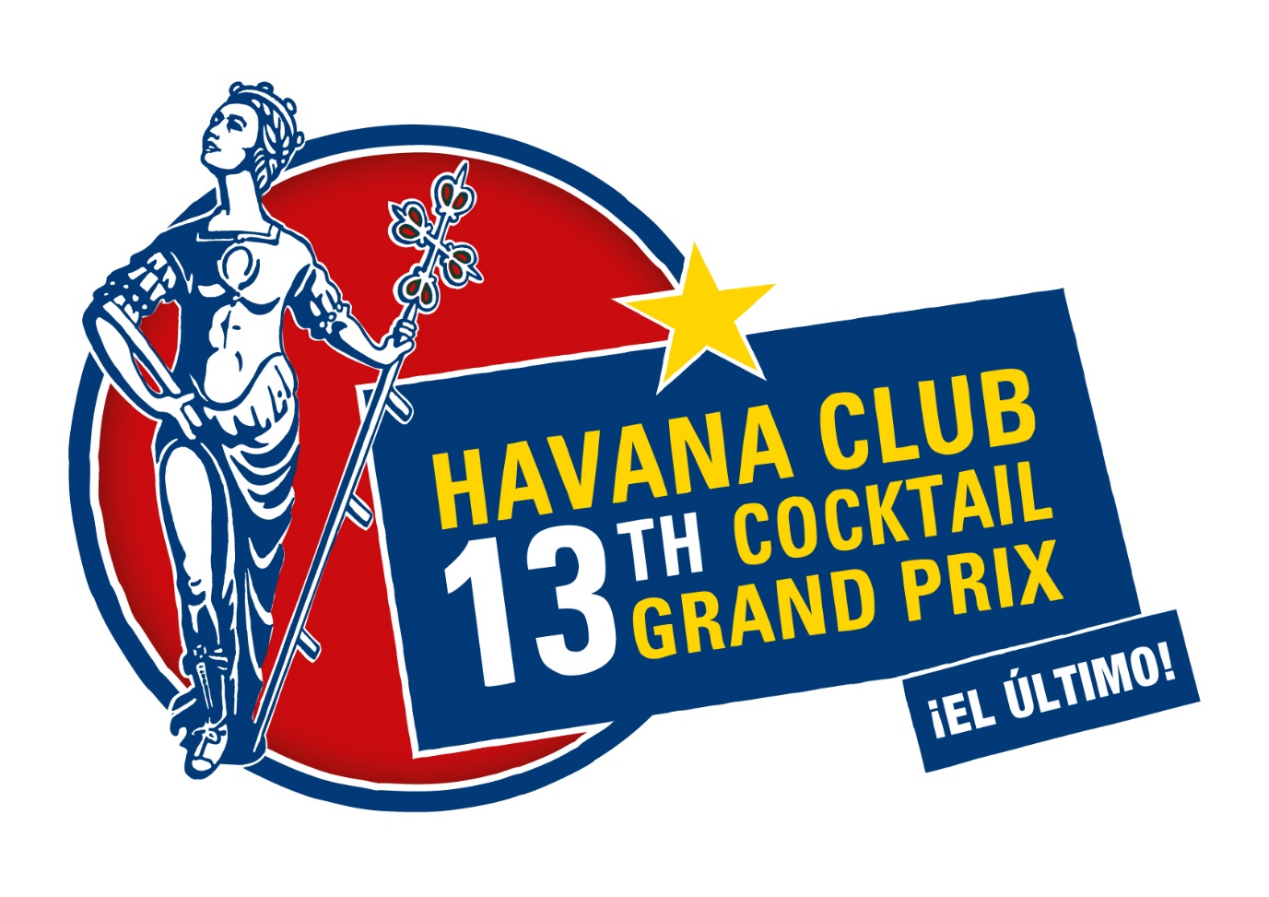
Dear participant, to attend the selection for Havana Club Cocktail Grand Prix National Heat please complete this application form in English.

Information about the participant:

Name and surname:
Date of birth:
City:
Bar:
E-mail:
Phone number:
SM accounts (Facebook/ Instagram):

Cocktail recipe:

Name of the cocktail
(! Don’t forget that your cocktail can’t be named after a public figure, whether they’re from Cuba or from any other country (eg.: “Fidel Castro Daiquiri” or “El Trump Presidente” or "Hemingway Mojito” or “Kanye Cancha”, etc.):

_________________________________

Write below all the ingredients of your cocktail and its quantity:
(! Please highlight the ingredient, which you use twice)

Quantity  (ml, g) | Ingredients
 | 1.
 | 2.
 | 3.
 | 4.
 | 5.
 | Garnish:

Making process description:___________________________________________

Garnish (making process):_____________________________________________

Serving glass (name):_________________________________________________

Homemade ingredient recipe

Name of the homemade recipe:_________________________________________

Write below all the ingredients of your cocktail and its quantity:
(! Don’t forget that homemade ingredients such as syrups, tinctures, pastes, etc. that are prepared for service prior to the competition can contain an unlimited number of ingredients and that finished preparation will be counted as a single, complete ingredient)

Quantity  (ml, g, dashes, drops) | Ingredients

Making process description:___________________________________________

Tell us about your inspiration. What is the connection between your cocktail, Cuban culture, retro drinks and modern style?

Answer:___________________________________________________________________

Photo of the cocktail
(! To pass the Selection, the photo of the cocktail must be eye-catching, impressive, as well as high-quality)

