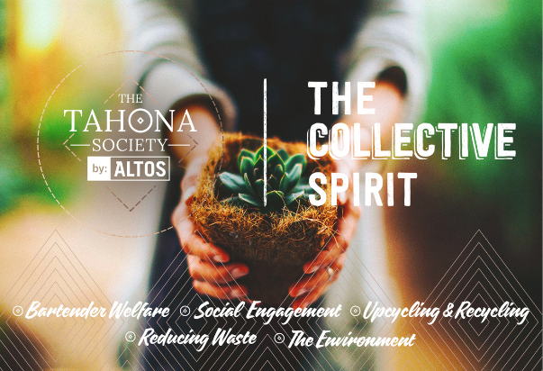

Tahona Collective Spirit Competition

Applicant’s surname and first name (or surname and first name of the responsible contact in the case of a group or organisation)
Date of birth
E-mail address
Telephone number
Facebook
Title of the project
Summary
Complete description of the project (no more than 500 words)

Declaration of intellectual property and independence from other sources of funding______________________________________________________

Applicants are encouraged to upload and attach to your email:
● Photographic images
● Sketches and graphics
● A short film (up to 3 mins)

